

Time: 3 Hours

Institute of [nformatioii Technology Jahangininpar University

2’d Year 1 Serrtester B.Ss. tHons.) Finai Esainin¥ion; 2018

Sub/etc: ›tlgod1hnl*no1*ie Scsson:2016.20t7

Cot Tilt:lTUl0t Full Mad‹s! 60

pptper any iv 5 from tiir fi›llou-ing questions, Figures ni the right iitdicote i)ie ninrks.



a) Expl.aim Efficiency of rim algorithm vitli cx:un plc Deduce the rtiniiing time efficiency' of 4 Sequeuti. I ze:trclt 2lgoritlzm.

b} Wh0T is Asymplolic ConJplcxif}' Gi\'e n 1 nrt description nhout D--notation and - rotation.

1. AJlnlyze lnsei1ion twit
2. Compare II\r urdei4 of' Pro \lh a/ - it(n - 1) ni\ñ nz.

2. »} SI o v ti›,t the l«i ¿c i clcn›ent in «ib te:e of. lie. p is iii the i'cot of ihc sub the. 2

bj \Vriie dr» n ilie al nriiliin *lleaI ifi’* to inniiiiaiii j{j¿ ]1enp ] yoperty. })]tlstrole the opcmtion of 3+3





re n« 5;¿ (, .?,) run trc army - 2i,l7.s, l6,ls,l0,l

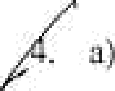

 



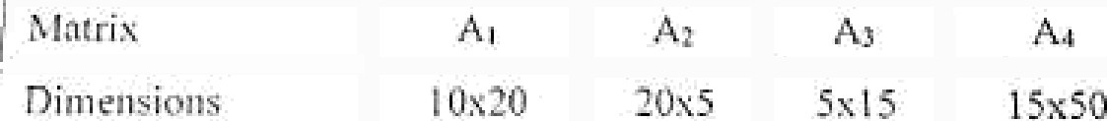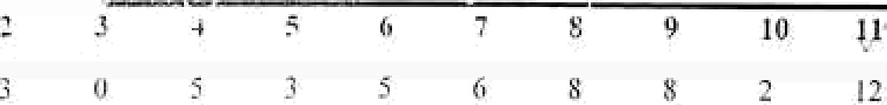

i

I

jolt I Ie »”.

I3) Wril« Juwtl II " hasil cuMc tel *uJ"/'‹’ml.t-r//ir›7t.*

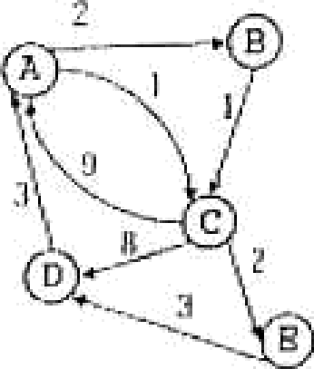



P.T.O

 Whflt arc the *0-I iaiapsack* mmd *fi acti•»«l* Kopsnc£ problem† HOW do yOu exp}Jpq



 the opti'' n S olu’

for these two problems and the other algorithm would fail, Cont} C£ o data file with 35000 clinrocters. The characters frequencies given by;

*›

in the file occur wity

|  |  |  |  |  |  |  |
| --- | --- | --- | --- | --- | --- | --- |
|  | C | d | g | h | j | k |
| frequency (in thousai d} | d | 9 | 3 | 4 | 7 | 6 |



Generntc the variatie length code woi'd usii' 8 ffii@ooo *code* n/gpriïfiin.

* ) Whnt * the nlgürilhm ofocriri/y *selecties problem* 3

1. a) Write down the *Priin 's algorilhni* to calciilate the /ninimu//i *.sfloTt* t*ln 8* ”*C ft*S ,’ O*• graph. 3

) Consider the following grapli, 4

10



6

Cpmpute the

minimum spaiuiing tree for the nbove mentioned B*• r* •°› 1 s *'r ›• ''

c} AppJy Kruskaï’s u lgarith m la £»d a •›i iw«i» spanning free of the following grephs. Does 5

Kruskal’s algorithm work cpirectly on graphs lllat have negatlve edge wcights?

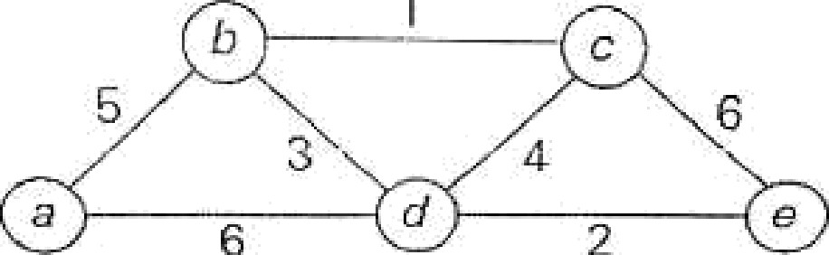

EMD

**ÎflSÎlttltC,** p( Infonnation Tecluiology

B .Sc(Honoi-s) 2"‘ J hangirnaga- University

Yeai’ 1"

# Seitiester Final Examination 2018

Full M<ks: so

Course: IT 2109(Stct lSÎÎCS 8nd Ptob«bility Theory)

# Time: 3 hours



[Answer any FIVE oPihe fOllOWiilg questions. Each sel of questions cnrry equnl marge

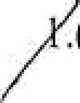.(a)What do you mean by StatlStÎOSŸ Write down the important applications où

# statistics in information technology. DRfine data with example. 4

# Define vai'iable with example. Briefly explain the qualitative and quantitative

# variable. 4

* 1. What is frequency distribution7 Why do yOU use Stl Gh dlsiribution? Why,

# giaph›ca1 presentation is so important? 4

# What is dispersion7 What are the measut’es of dispersion* 4

1. Wi’ite down the merits and demei its of inean deviation and standard

# deviation.4

# A frequRncy distribution of weights (in k )of 45 students are given below:



încome iit Taka

uenc

50-St

55-60

60-65

65-70

)0

70-75 75-80

# Compute the mean dcviation and coefhcient of variation, 4

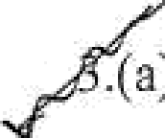*. B )* Wttat iS COefficient of variation (CE)? Why coefficient of variation is so

# important? 4



t

# Establish the relation between q’s and v’s. 4

1. Compute the ktirtosis (baked upon the fourth moment about the mean)of

J\ ‘" the following frequency disti ibution, 4

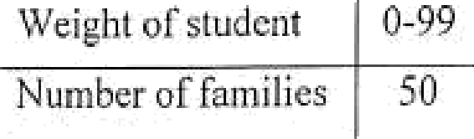s‘

|  |  |  |  |  |  |  |
| --- | --- | --- | --- | --- | --- | --- |
| Wright of studcnt 0-99  Number of familier 50 | I 00-î 99 | 200-299 | 300-399 | 400-499 | JD0-599 | 600-d99 |
| 70 | 203 | 408 | 403 | 42 | 5 |

# Write down the user Cit COlTRlation coefflcient. 3

# The followiiig table shows lhe data of the heights of falher and h:is son 9

|  |  |  |  |  |  |  |  |  |  |
| --- | --- | --- | --- | --- | --- | --- | --- | --- | --- |
|  | |  |  |  | 168 | 167 | 169 | 170 | 172 |
|  | i [cij i« «mon(cnn)  (t) | 157 | UR | 145 | 172 | UÔ | 172 | 169 | 171 |



 



the lci iris cxpci'iiTicnl, sniiip!c sj›iicc o»d c e»i wiih exnmple. Write

* 1. TwD tllOllSili1‹1 i iintloinly selected adults wclc asked if they think they ara financially better off than their parents. The following table gives the two- way classification of the responses based on the education levels of the

pcrson5 included in the survey and whether they are tnancially

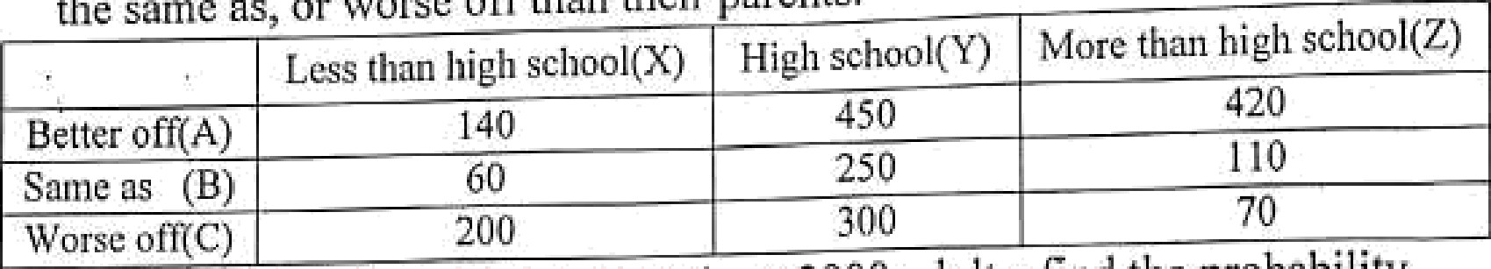the some as, or › orse orra«n their parents.

better om,



Les titan high school(X) HÎgl15G oo1(Y)

îvtore than high school(Z)

Detier off(A) 140

Saint as (B) 60

Worss otgC) 200

450

250

420

110

70

lf one adult is selected at ’i andoin from thèse 2000 adiilu, find the probability

that ihis adult is

* + 1. P(FinenciaIly better off given less thnn high school)
    2. P(High school given flnaiicially worse off)
    3. P(better off ond high school)
    4. P(more than high school and worsc off)

fritedown the conditions nf a binoinial experiment.2

1. According to a National Public Radio poil, 46% of' A merican school

plincipals believe that students pay little attention to science education pi ovided in schools. Suppose that this reeult is true for the current population of American school principals. 10

* 1. Let *x* be a binoinial random variable denoting the number of American

school principals in a randoiu sainple où 7 who do not believe that

students pay litÎle attention to science education taught in sehools. Write

I

the probability distribution of sand drap ri graph of the probubility

distribuÛon. Determîne the ineari and standard deviation cfr.

*ii ) Find* the probRbility that in a random sample of 7 American school principals, at mo.st 4 beiieve that students pay little attention to science education taught in schools.

7. (a)Define hypothesis. What is null alid alternative hypothesis? Define level

of significance.4

1. What is power of the test and p-value? Define confidence interval with example.
2. Suppose the manager of a textile industry suspects that the mean time lost doc to the sickness of the night shifl workeis excecds the mean time foi the day shi h workciz. To check it, the manager randomly selected 12 workers ill cach sllifi cotcgoiy »n‹1 ircoi‹I tie »tiiiibor or“ dnys lost dtie to sickness

|  |  |  |  |  |  |  |  |  |  |  |  |
| --- | --- | --- | --- | --- | --- | --- | --- | --- | --- | --- | --- |
| Night Chili | 12 | 10 | 20 | 1. 5 | 18 | 9 | 12 | 10 | 21 | 25 | 13 |
| Day Shifl | ä | 10 | 15 | 9 | 12 | 16 | 15 | 20 | 5 | 18 | 12 |

If the Humber of’days |7el' year lost chic to the sicluiess for thc night shift

and day slii fl k ’s NIJ ])Q] lually t!ish ibiited with mean pi and pi and

varpiance

and z$ respectively, test the significance of the difference of

populatinn inenns if the population variances are mot equal. The table value is at 5% level nf significance is 1.72.